MACH4METAL

Metalworking machinery
Transito 21,
6909 DA BABBERICH
Netherlands
Tel. +31 (0)316 – 247123
Fax. +31 (0)316 - 247956
info@mach4metal.com
www.mach4metal.com

Account No: 66.52.13.883
IBAN : NL33 INGB 0665 2138 83
BIC : INGBNL2A

CNC Universal bed miller ZAYER 20 KFU 3000
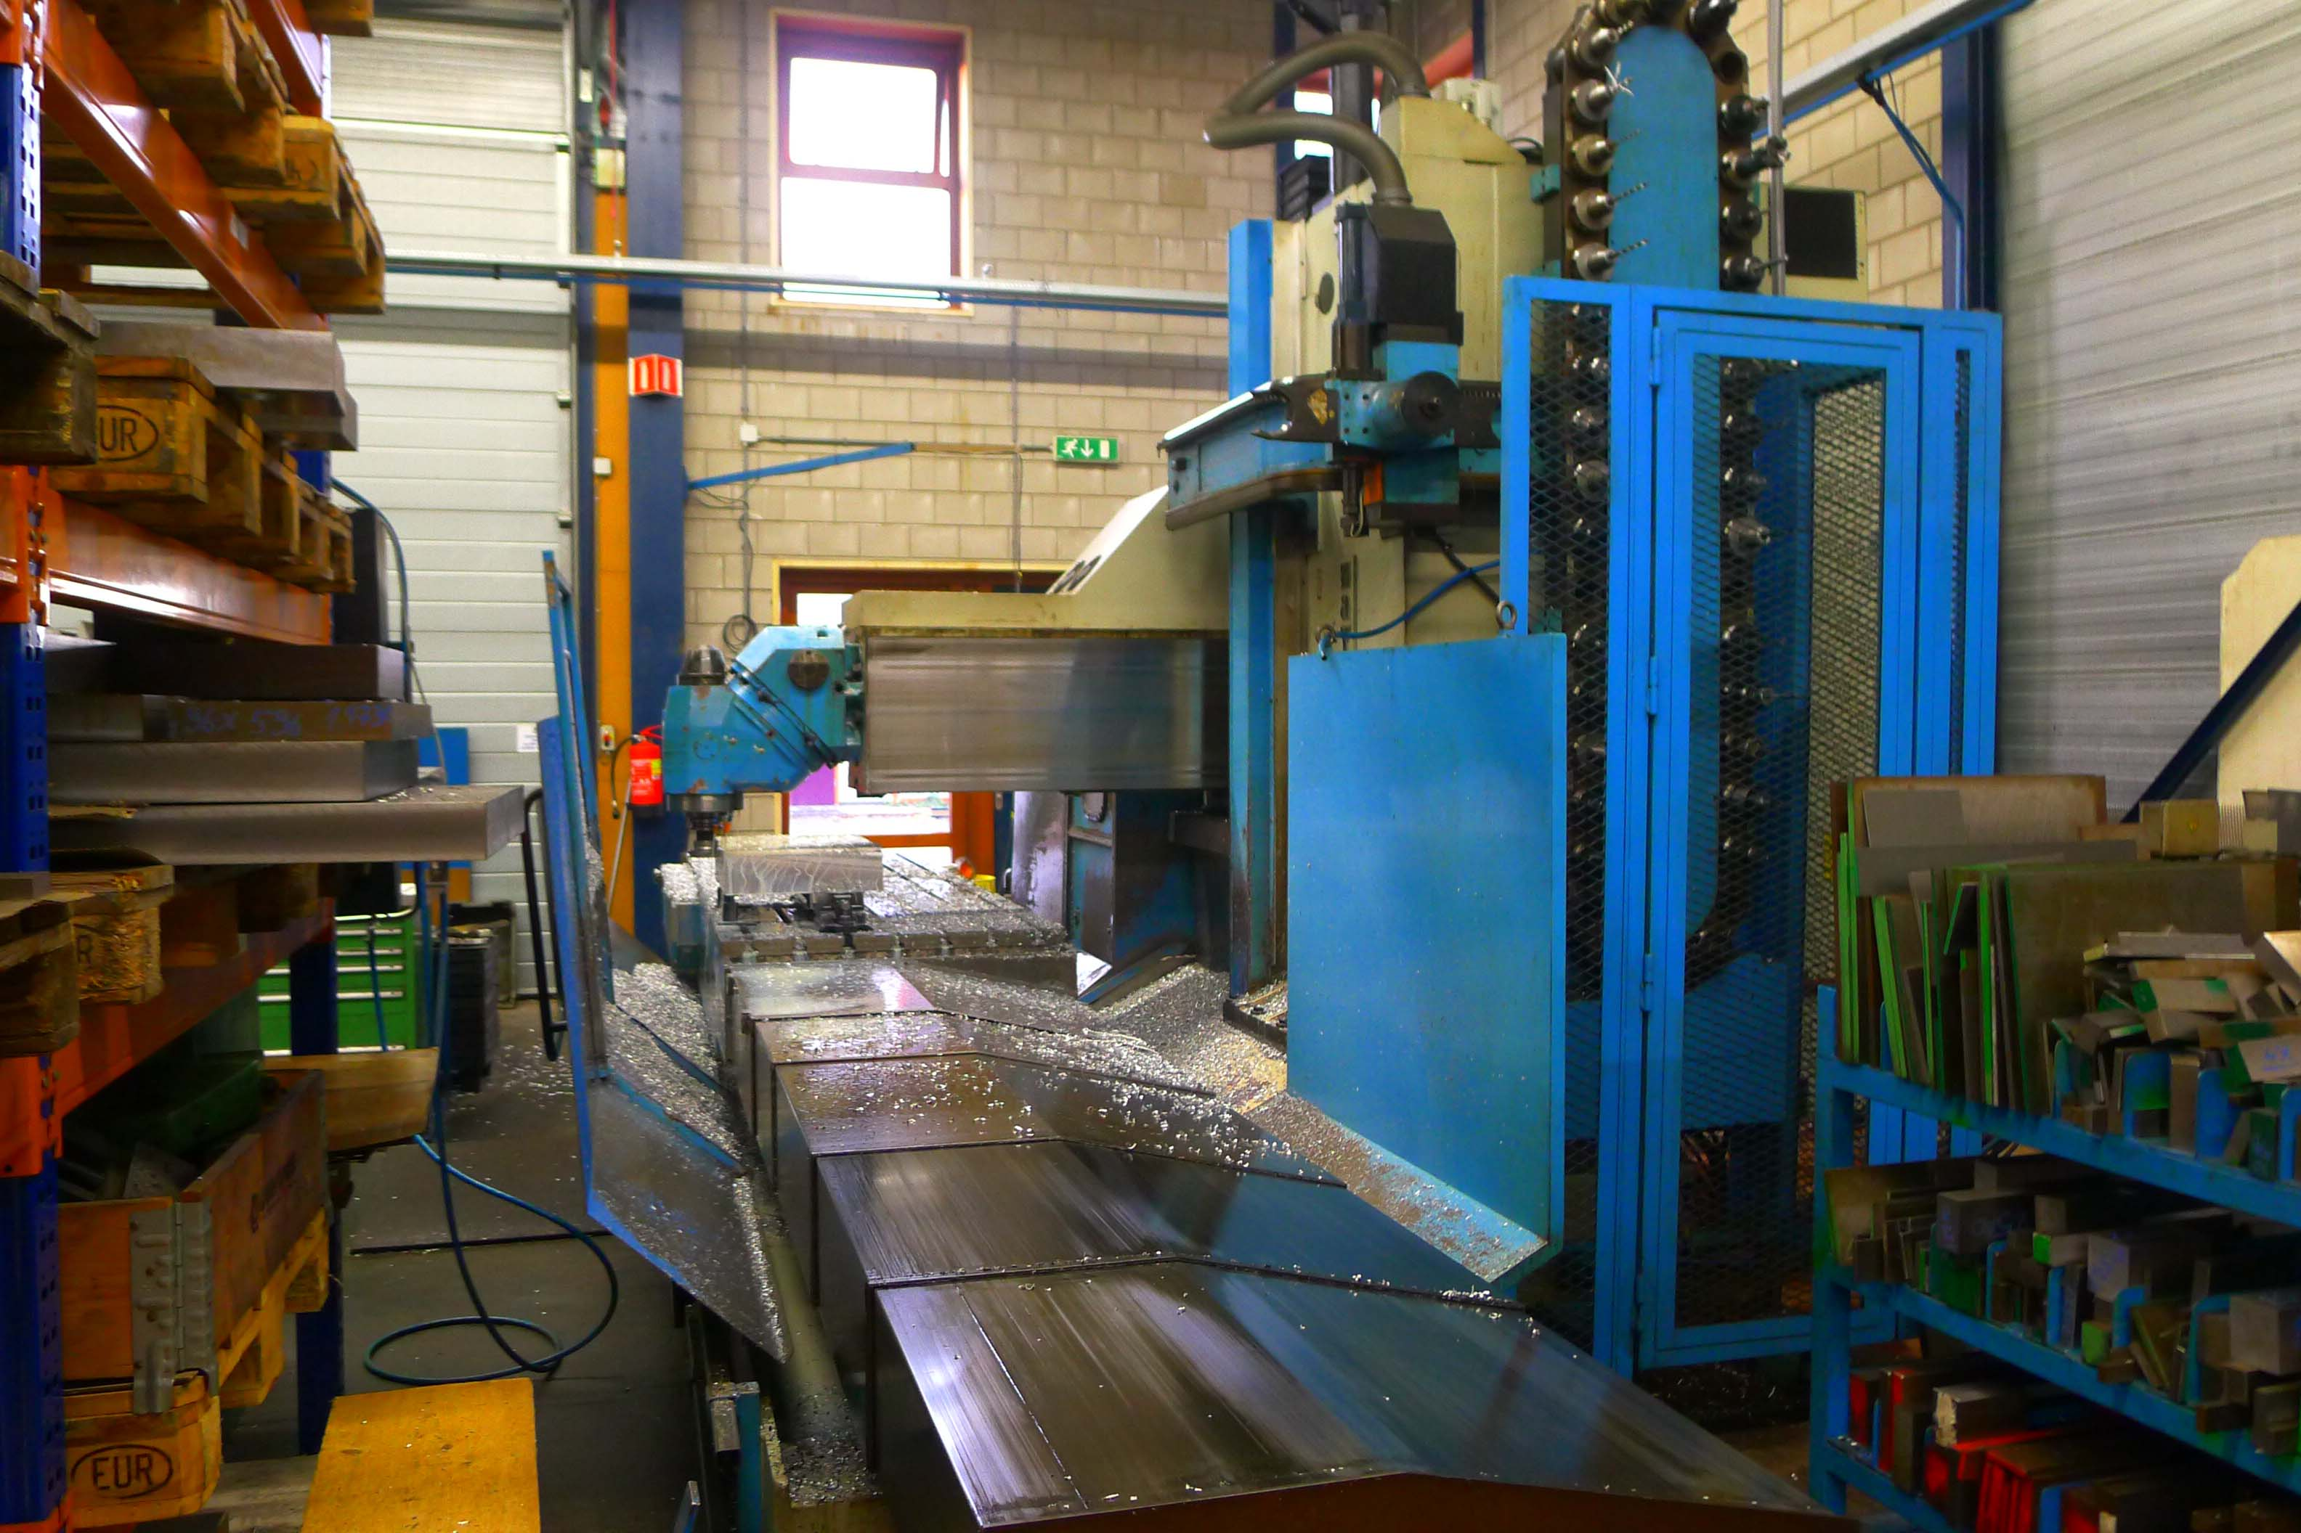

- Make : ZAYER - Spain
- Typ : 20 KFU 3000
- No. : 29088
- Age : 1995
- CNC : TNC 426 HeidenHain

- X Travel : 2.709
- Y Travel : 1.212
- Z Travel : 1.501
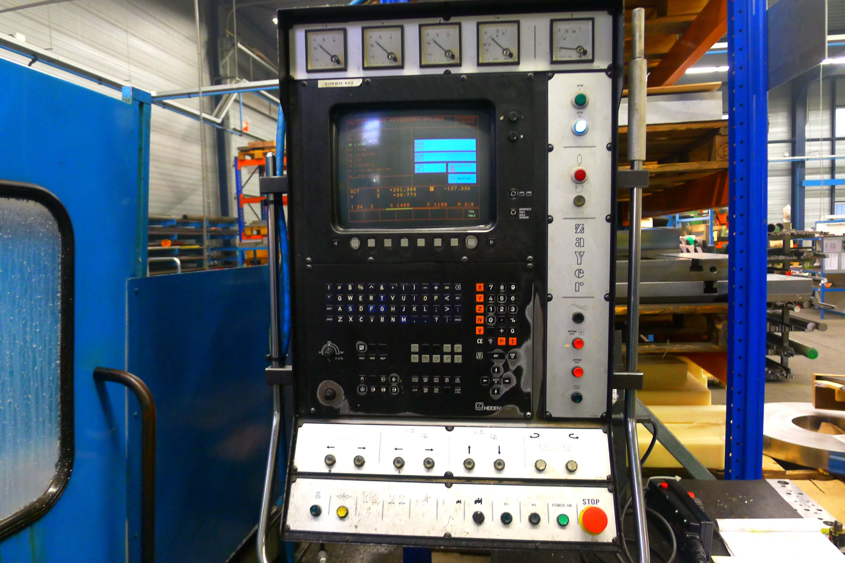
- Table length : 3.000
- Table width : 1.000
- Table load : 10 T

- Spindle taper : Iso 50
- Spindle speeds : 1800 Rpm
- Spindle power : 28 kW

- Rapid Feed rate : 15.000 mm/Min
- Feeds all 3 axis : 5.000 mm/Min
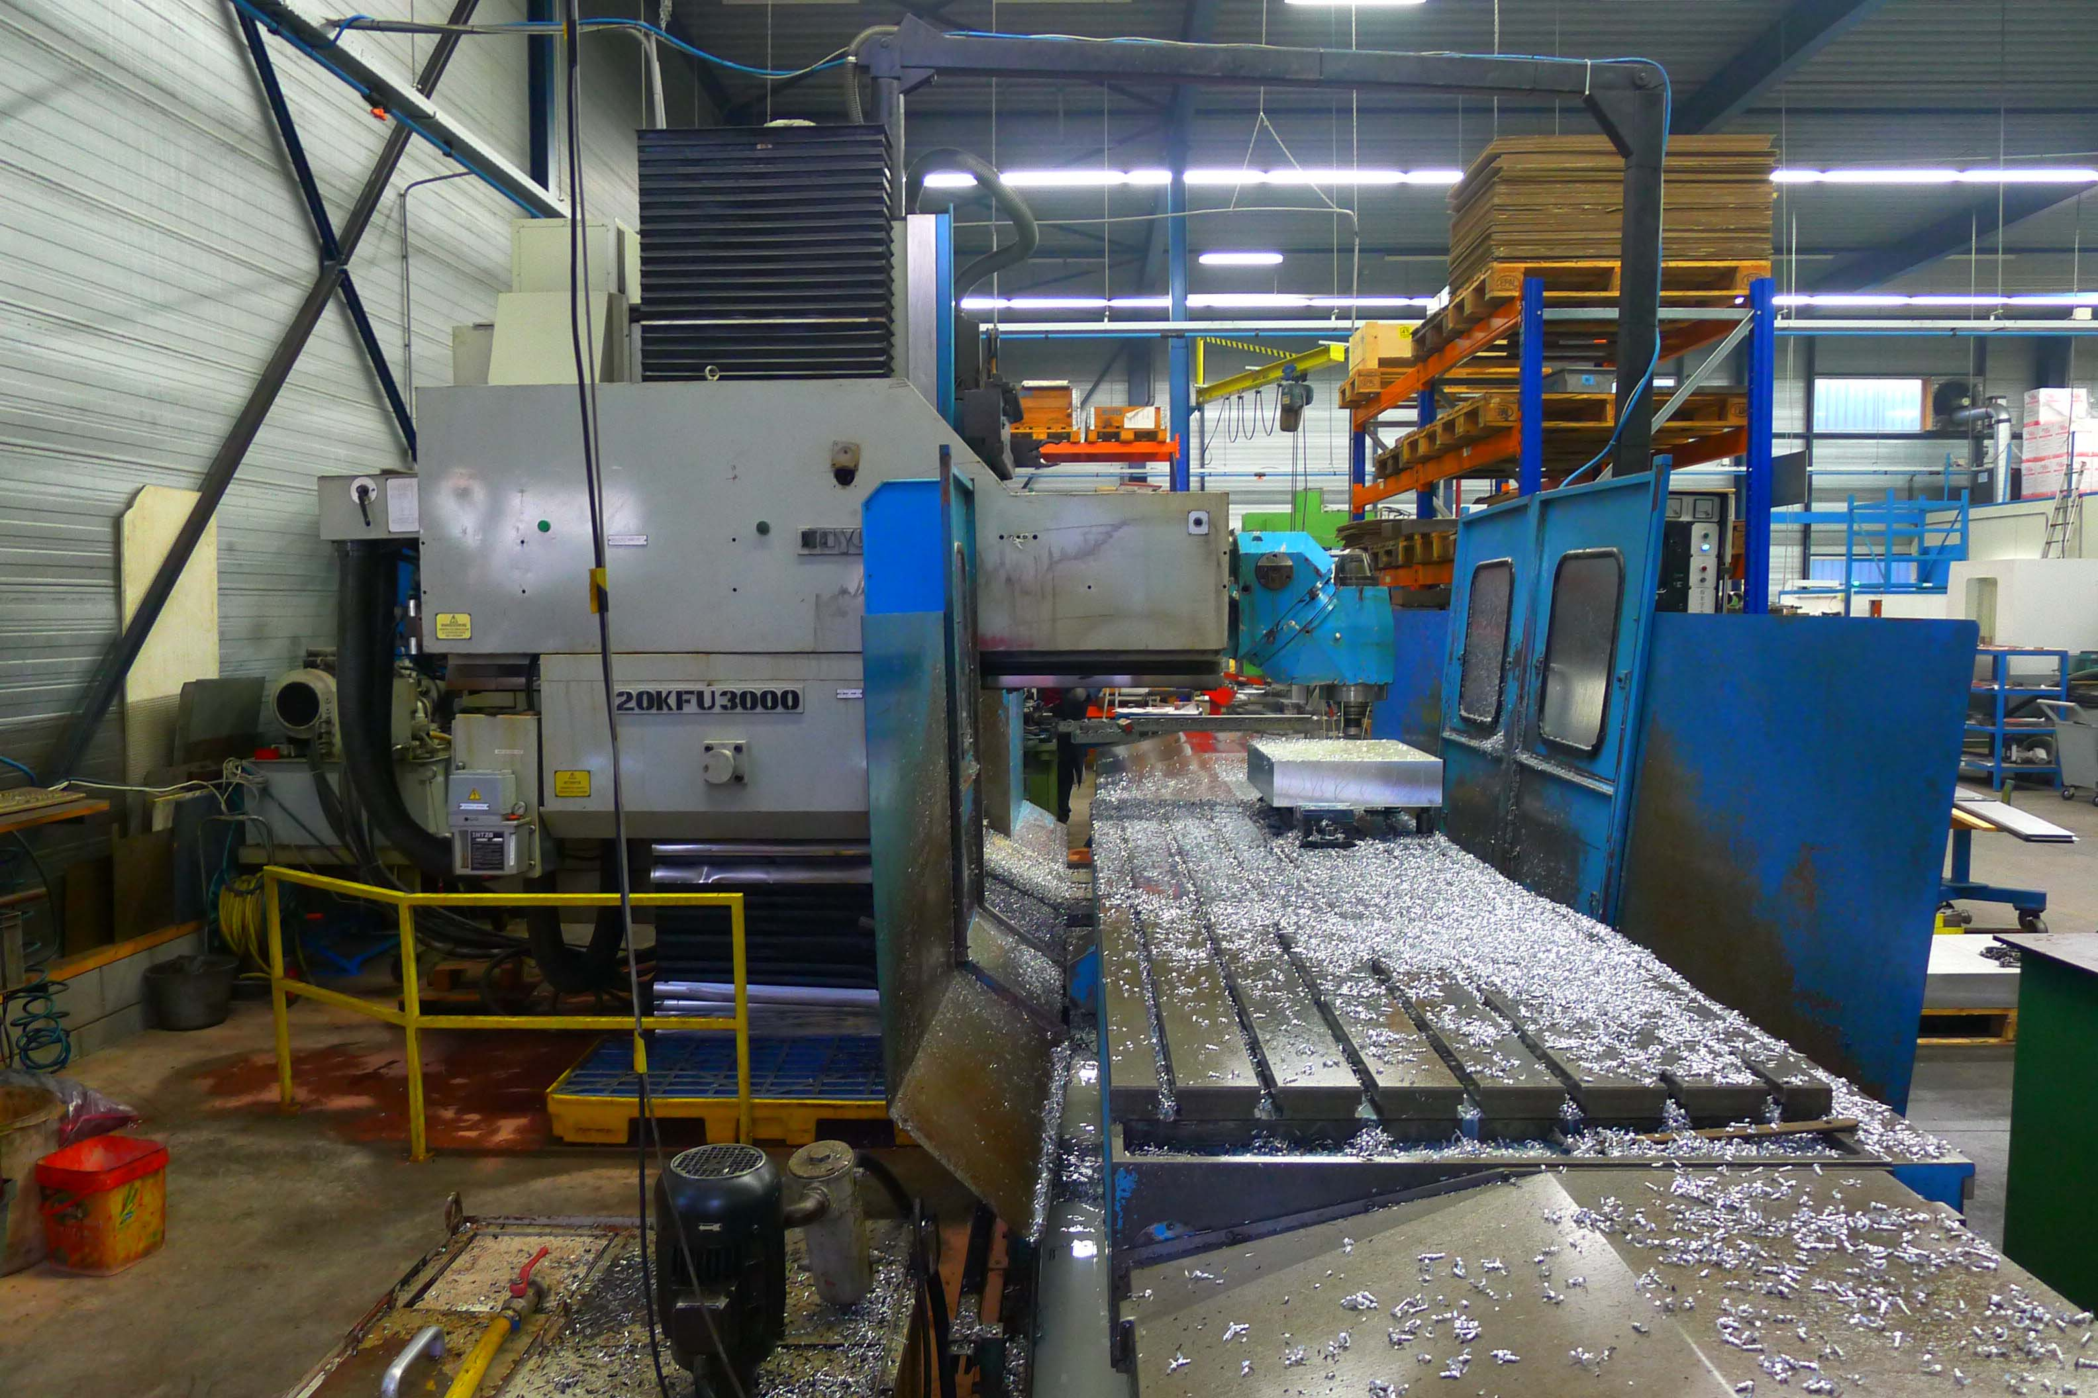
- Dimensions
- Length : 7.400
- Width : 4.275
- Height : 3.915
- Weight : 18.200 Kg

- Chain ATC with 40 positions
- NC Universal milling head Hor + Vert
- Under power !
- Large tooling package

Please Note: The above information has been obtained to the best of our ability and belief from, and from the manufacturers where possible. It is given in good faith, but its accuracy can not be guaranteed. Accordingly, it will not form a representation or constitute contractual terms. We advise you to check any vital details !

\

